# Build guide:

Assumed is a knowledge of the basics of your raspberry pi such as how to log in and install software. If not, don’t worry. There is a great deal of help out there on the web. Getting started is not hard.

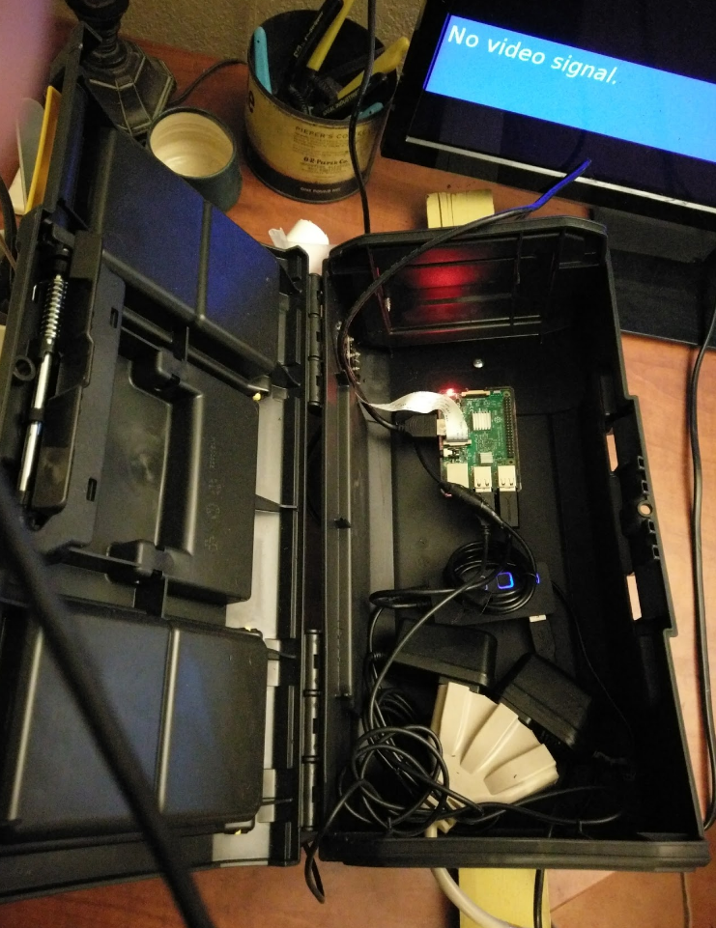

Figure 1. This is the box with the pi, powered USB hub, and power supplies.

## Parts:

### Choose a Raspberry Pi camera (the ones with the ribbon cable).

I chose something like this….

Waveshare Raspberry Pi Camera (F) Night Vision Camera Adjustable-Focus Module 5MP OV5647 Webcam Video 1080p for Raspberry-pi 3 Model B/ 2 B/B+

### Choose a USB night vision security camera…

ELP 1megapixel Day Night Vision Indoor&outdoor Cctv Usb Dome Housing Camera

### Get a box to put everything in…

I just used a $15 plastic Stanley toolbox from Ace hardware - it worked GREAT as a water proof case for the raspberry pi, a powered usb hub, and power connectors (plenty of space and easy to cut with a Dremel). Here is the link...

<http://www.acehardware.com/product/index.jsp?productId=11697110&cp=2568443.2568450.2628082.2629228>

I’ve been really impressed with this box as a case. It has protected the pi against monsoon rains and 110+ degree temperatures and other abuse without a hitch for > 1 year.

### Get a powered USB hub…

There are many on amazon. You will need this as the raspberry + usb camera sucks a lot of power.

### Get a decent outdoor extension cord …

This is not battery powered. I did not want to deal with changing batteries so I kept this setup wired and not battery powered. The setup is power hungry so a battery would probably not even last a day.

## Install hardware.

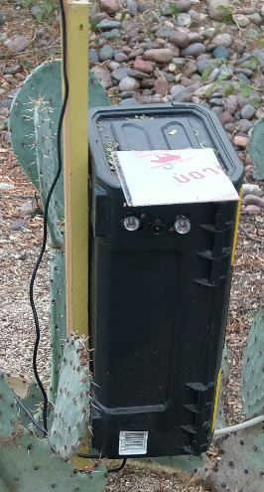

Figure 2 The pi in action. I screwed in a plastic visor on top to keep off some of the rain and sun. Note the holes for the camera and IR lights.

1) Plug in the day/night raspicam using the ribbon cable with the blue part of the ribbon facing away from the HDMI port. Google this and other basic info on working with the raspicamera. You need to sudo raspi-config and enable the camera. There are many good tutorials for getting the camera up and running on the web.

2) Plug in a second USB camera into one of the free usb ports on the pi.

3) Get all of the software working as described in INSTALL_AND_README.txt

4) Once it’s working, just make some stakes for mounting the box and USB camera. I used a wood stake for the toolbox and a PVC pipe for the USB camera.

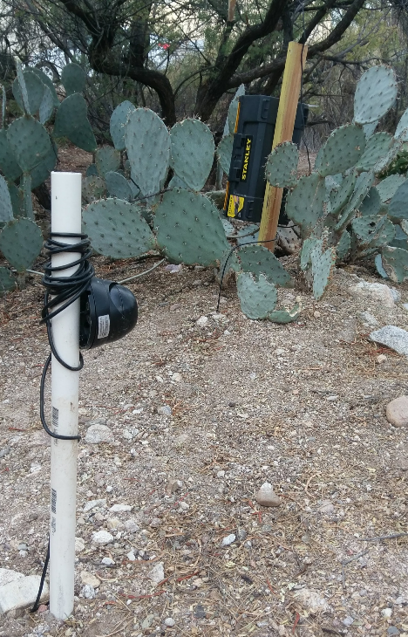

Figure 3 This is the attached USB camera. I buried the cable. It runs into the box.

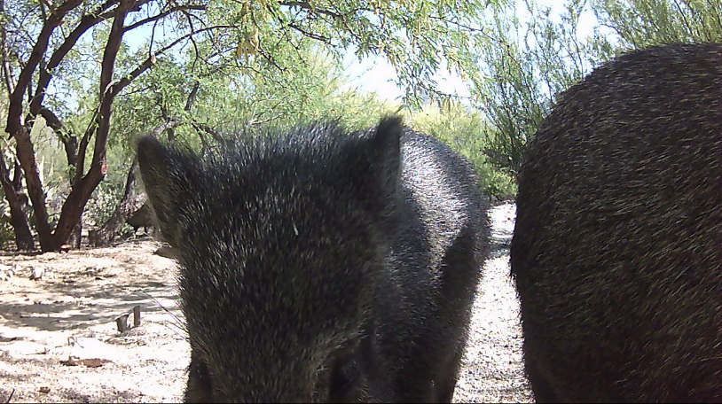

Figure 4 Up close with two javalinas.